Nub Labs
Yard Robot Prototype
March Development Update [confidential]
3/31/2009

Eric & Gerald,
In the past few weeks Nub Labs has created a design and build schedule and purchased the bulk of the parts needed to build the prototype. Of note, we have attained and begun working with:
- Aluminum frame with motors, wheels, control circuitry, battery
- H₂S sensors
- Netbook
- Data acquisition circuitry (sensor-computer interface)
- Range sensors and pressure sensors
- Metal and plastic for building a cover for the chassis
- Assorted brackets for mounting all components onto frame
The current robot is shown in Figure 1:
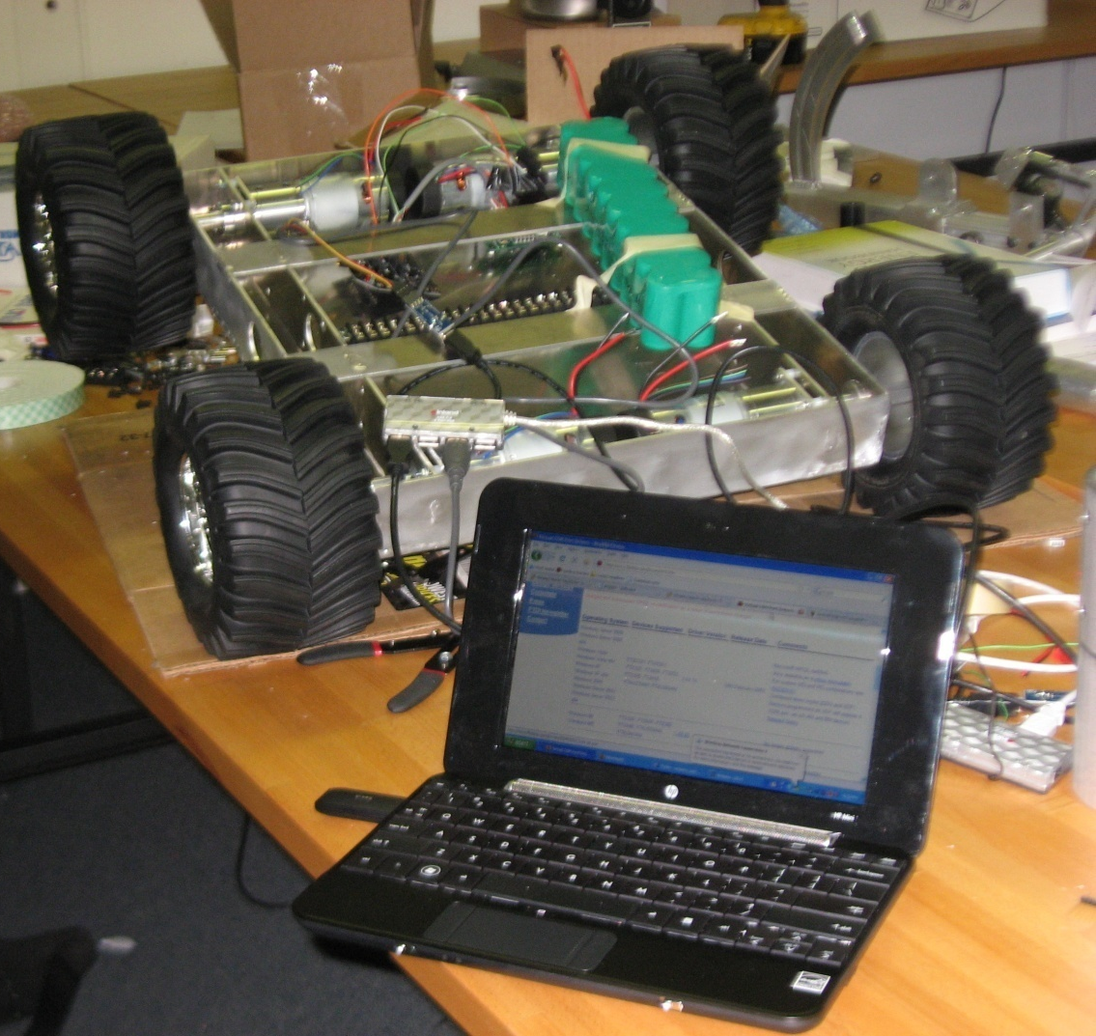
Figure 1: Robot Prototype as of 3/30/2009

We have split the design and build process into three milestones: basic yard navigation, sensing poop, reacting to poop.
Basic yard navigation contains all of the fundamental robot actions – driving around a yard, dealing with obstacles, and performing predictably. Tasks involve building the mechanical, electrical, and software infrastructure of the robot so that it can do interesting in novel things later. We are confident that we will complete this milestone in the next few weeks.
Sensing poop involves ordering, testing, and integrating H₂S sensors into the robot design. Within the timeframe of this prototype, this is about surveying available sensors and finding a way to make them work. As we have found no literature involving H₂S sensors and robotics/automation, this process contains some uncertainty. We’ve received some H₂S sensors and will be testing them soon. We will report our findings as we learn more about this process.
Reacting to poop is the process of the robot visually highlighting or physically removing poop identified by the H₂S sensors from a yard. We have not performed significant detailed design work on this milestone. The design and capability of this milestone will largely driven by the functionality and limits of the poop sensing.

Overall, we’re systematically knocking off the fundamental robot stuff and exploring the technologies that will make this prototype novel and functional.
If you have any further questions or requests, please do not hesitate to contact us.
Regards,
Will & Alex

